|  |  |
| --- | --- |
| Unit 4 | Applications Review |

|  |  |  |  |
| --- | --- | --- | --- |
| **1.** | A 12 foot ladder is leaned against a wall. If the base of the ladder is 2 feet from the wall, how high up the wall does it reach? | **2.** | A 60 foot ramp has an angle of elevation of 12°. Find the vertical rise of this ramp. |

|  |  |  |  |
| --- | --- | --- | --- |
| **3.** | A 10 foot Ladder is leaned against a wall. If the ladder reaches 8.5 feet up the wall, find the angle of elevation of this ladder. | **4.** | Mark has an eye-level of 5.5 feet. He is looking at the top of a tall tower with an angle of elevation equal to 50°. If Mark is standing 100 feet from the tower, find the height of the tower. |

|  |  |  |  |
| --- | --- | --- | --- |
| **5.** | The following sides of a triangle are given:  4 cm, 12 cm, and 13 cm. Classify the given triangle. | **6.** | Two rangers are 14 miles apart along a service road. The spot a fire north of the road. Ranger A spots the fire with a line of sight at 40°, while Ranger B at 60°. Find the distance each ranger is from the fire. |

|  |  |  |  |
| --- | --- | --- | --- |
| **7.** | A pilot normally flies 200 miles from city A to city B. To avoid a storm, she must first fly 50 miles to city C, and then 150 miles on to city C. What angle must she turn the plan at city C to arrive at city B? | **8.** | Jenny is standing on a 400 foot cliff looking down at a whale in the ocean. She looking down with an angle of depression at 64°. If her eye level is at 5 feet, estimate how far the whale is from the base of the cliff. |

|  |  |  |  |
| --- | --- | --- | --- |
| **9.** |  | **10.** |  |

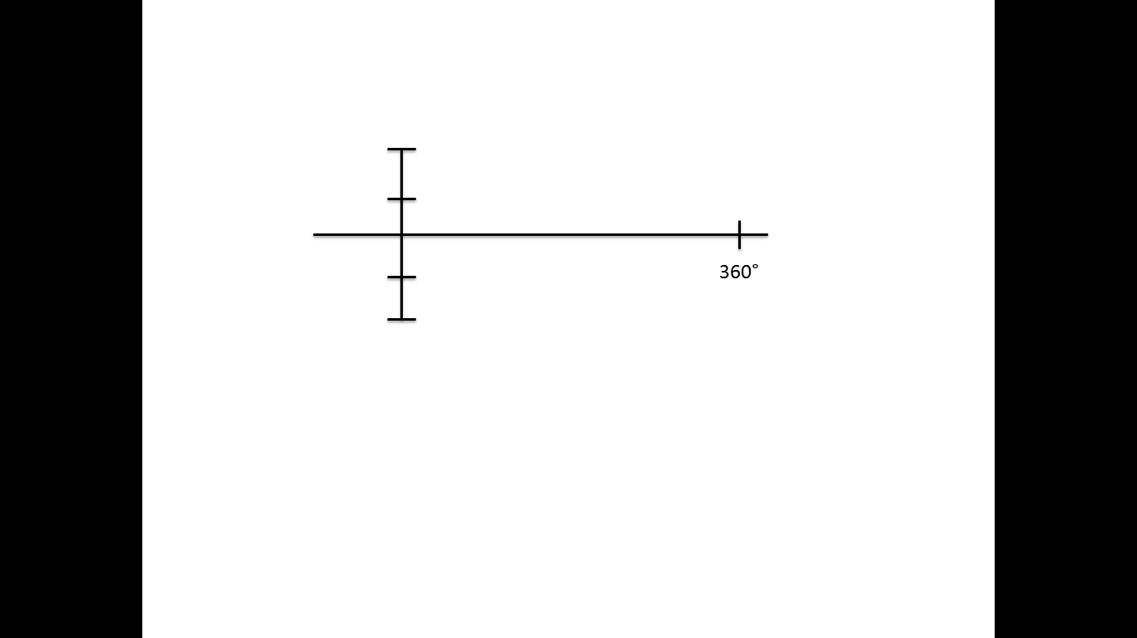

**Cycles: Cycles:**

**Period: Period:**

**Amp: Amp:**

**Dom: Dom:**

**Ran: Ran:**

|  |  |  |  |
| --- | --- | --- | --- |
| **9.** |  | **10.** |  |



**Cycles: Cycles:**

**Period: Period:**

**Amp: Amp:**

**Dom: Dom:**

**Ran: Ran:**